DAYANANDA SAGAR UNIVERSITY
Devarakaggalahalli, Harohalli
Kanakapura Road, Bengaluru South Dt - 562112, Karnataka, India



Bachelor of Technology in
COMPUTER SCIENCE AND ENGINEERING

Major Project Phase-II Report
Intellectual Smart Hybrid AI System for Real-Time Threat Intelligence in the Internet

Batch: 89
By
NU Chinnappa - ENG22CS0377 Sriram Puranik - ENG22CS0467 Tejas KM - ENG22CS0480
Kalyan Gogoi - ENG23CS1031 Under the supervision of
Dr. Naitik S T

Assistant Professor, CSE

DEPARTMENT OF COMPUTER SCIENCE & ENGINEERING,

SCHOOL OF ENGINEERING DAYANANDA SAGAR UNIVERSITY,
(2025-2026)

DAYANANDA SAGAR UNIVERSITY


Department of Computer Science & Engineering Devarakaggalahalli, Harohalli, Kanakapura Road, Bengaluru South Dt - 562112 Karnataka, India

CERTIFICATE

This is to certify that the Major Project Stage-II work titled “Intellectual Smart Hybrid AI System for Real-Time Threat Intelligence in the Internet” is carried out by Sriram Puranik (ENG22CS0467), NU Chinnappa (ENG22CS0377), Kalyan Gogoi (ENG23CS1031), Tejas Km (ENG22CS0480), bonafide students Eight semester of Bachelor of Technology in Computer Science and Engineering at the School of Engineering, Dayananda Sagar University, Bangalore in partial fulfillment for the award of degree in Bachelor of Technology in Computer Science and Engineering, during the year 2025-2026.

Dr. Naitik ST Dr. Girisha G S Dr. Udaya Kumar Reddy K R

Assistant Professor Dept. of CS&E, School of Engineering
Dayananda Sagar University Date:
Chairman CSE School of Engineering
Dayananda Sagar University Date:
Dean
School of Engineering Dayananda Sagar University
Date:

Name of the Examiner Signature of Examiner

1.

2.

3.

DECLARATION

We, Sriram Puranik (ENG22CS0467), NU Chinnappa (ENG22CS0377), Kalyan Gogoi (ENG23CS1031), Tejas Km (ENG22CS0480), are students of the Eight semester B.Tech in Computer Science and Engineering, at School of Engineering, Dayananda Sagar University, hereby declare that the Major Project titled “Intellectual Smart Hybrid AI System for Real-Time Threat Intelligence in the Internet” has been carried out by us and submitted in partial fulfilment for the award of degree in Bachelor of Technology in Computer Science and Engineering during the academic year 2025-2026.

Student Signature

Name1: Sriram Puranik
USN : ENG22CS0467
Name2: Tejas KM
USN : ENG22CS0480
Name3: NU Chinnappa
USN : ENG22CS0377
Name4: Kalyan Gogoi
USN : ENG23CS1031

Place : Bangalore Date :

ACKNOWLEDGEMENT

First, we take this opportunity to express our sincere gratitude to School of Engineering & Technology, Dayananda Sagar University for providing us with a great opportunity to pursue our Bachelor’s degree in this institution.

We would like to thank Dr. Udaya Kumar Reddy K R, Dean, School of Engineering, Dayananda Sagar University for his constant encouragement and expert advice.

It is a matter of immense pleasure to express our sincere thanks to Dr. Girisha G S, Department Chairman, Computer Science and Engineering, Dayananda Sagar University, for providing right academic guidance that made our task possible.
We would like to thank our guide Dr. Naitik ST, Assistant Professor, Dept. of Computer Science and Engineering, Dayananda Sagar University, for sparing his/her valuable time to extend help in every step of our project work, which paved the way for smooth progress and fruitful culmination of the project.

We would like to thank our Project Coordinators Dr. Sivananda Lahari Reddy, Dr. Kumar Dilip and Dr. Naresh P as well as all the staff members of Computer Science and Engineering for their support.
We are also grateful to our family and friends who provided us with every requirement throughout the course.

We would like to thank one and all who directly or indirectly helped us in the Project work.
.

TABLE OF CONTENTS

LIST OF FIGURES 11
ABSTRACT 8
CHAPTER 1 INTRODUCTION 9
CHAPTER 2 PROBLEM DEFINITION 10
CHAPTER 3 LITERATURE SURVEY 11-13
CHAPTER 4 PROJECT DESCRIPTION 14-15
CHAPTER 5 REQUIREMENTS 16-20
CHAPTER 6 METHDOLOGY 21-23
CHAPTER 7 EXPERIMENTATION 24-30
CHAPTER 8 RESULT 31-39
CHAPTER 9 DELIVERABLES 40-44
REFERENCES 45-46

NOMENCLATURE USED

Acronym/Term | Full Form / Definition
IS-HAITI | Intellectual Smart Hybrid AI System for Real-Time Threat  Intelligence in the Internet
GNN | Graph Neural Network
GCN | Graph Convolutional Network
GAT | Graph Attention Network
SAGE | GraphSAGE (Inductive representation learning on large graphs)
SMOTE | Synthetic Minority Over-sampling Technique
X-TIS | Explainability & Transparency Intelligence System
CADA | Continuous Adaptation & Defense Architecture
TCN | Temporal Convolutional Network
C2 | Command & Control
IDS | Intrusion Detection System
IPS | Intrusion Prevention System
SOC | Security Operations Center
APT | Advanced Persistent Threat
XAI | Explainable Artificial Intelligence
DLP | Data Loss Prevention
EDR | Endpoint Detection & Response
NSL-KDD | NSL-KDD Network Intrusion Detection Dataset
CICIDS | Canadian Institute for Cybersecurity Intrusion Detection System Dataset
PCAP | Packet Capture file format
CSV | Comma-Separated Values
ROC-AUC | Receiver Operating Characteristic - Area Under the Curve
F1-Score | Harmonic mean of Precision and Recall
MFA | Multi-Factor Authentication
DNS | Domain Name System

LIST OF FIGURES

Fig. No. | Description of the figure | Page No.
1 | Fig 1: System Architecture | 14
2 | Fig 2: High-Level Workflow of the IS-HAITI Threat Detection System | 21
3 | Fig 8.2: Pooled ROC curves (Our-GNN vs baselines, 5-fold CV) | 32
4 | Fig 8.3: Top services by predicted attack probability | 33
5 | Fig 8.5: NetBIOS/SMB-related subgraph | 34
6 | Fig 8.6: PM_Dump subgraph and attribution view | 35
7 | Fig 7: NetBIOS_DGM / DNS anomaly-style subgraph | 35
8 | Fig 8: SMS Spam Collection Text Threat Analysis Report | 38
9 | Fig 9: Easy Ham Email Text Threat Analysis Report | 38
10 | Fig 10: Screenshot of Category A HTML report (spam/phishing) | 39
11 | Fig 11: HTML Report Graph Based on attacks | 39

ABSTRACT

Most intrusion detection systems today work at the level of individual network connections. They look at a single packet or flow and decide whether it looks malicious. This approach has a known weakness: many real attacks are spread across multiple connections and multiple services, and no single connection looks suspicious on its own.

IS-HAITI is a hybrid AI-based threat detection and intelligence system that covers all of these threat types under one platform. It combines a Transformer model for network flow analysis, a Graph Neural Network for detecting coordinated attack behavior across services, a rule-based engine for known patterns, a content classifier for spam and phishing text, a URL analyzer for malicious links, and a deepfake detector for synthetic media. Only the models relevant to the input type activate, and every detection is explained by X-TIS using SHAP and LIME telling the user exactly which signals triggered the alert, not just that something was flagged.

The framework integrates learned model outputs with rule-supported analysis and produces structured detection reports together with explainability outputs through the Explainable Threat Intelligence System (X-TIS). The system demonstrates capability in identifying phishing and spam communications, malicious URLs and credential harvesting websites, network reconnaissance activities, brute-force authentication attempts, service enumeration patterns, and botnet-related communication behavior.

CHAPTER 1 INTRODUCTION

Cyber attacks scans the network to see what is available, Then they move around inside the network. Then they quietly take data out If you look at any one of these steps on its own, it might not look suspicious. It is only when you look at all the steps together, across different services, that the attack pattern becomes clear. Most intrusion detection systems miss this because they examine each network connection in isolation.

The increasing complexity of cyber-attacks has created significant challenges for traditional network security systems. Modern attackers rarely rely on a single exploit instead, attacks typically involve multiple stages such as credential attacks, malicious communication establishment, and persistence mechanisms. These activities often appear normal when analyzed independently but reveal malicious intent when behavioral and structural relationships are considered together.

IS-HAITI addresses both of these problems. For network traffic, it uses two layers of analysis. The first layer is a Transformer model that scores each individual connection. The second layer is a Graph Neural Network (GNN) that looks at how services in the network communicate with each other as a group, which is where multi-stage attack patterns become visible. For non-network threats, it has separate modules for URL analysis, text message analysis, and deepfake detection. All of these sit behind a rule-based verification engine and an explainability system called X-TIS that tells the user exactly why something was flagged.

Our project framework focuses on hybrid cyber threat analysis by combining behavioral learning models. The system learns attack behavior from multiple intrusion detection datasets and evaluates how risk propagates across interacting services. Instead of replacing traditional approaches, the framework integrates learning-based intelligence with interpretable analysis outputs.

CHAPTER 2 PROBLEM DEFINITION

Our project addresses a major limitation in current threat detection systems, which typically analyze data in isolation, rely on a single model, and fail to provide meaningful explanations. Existing machine learning-based intrusion detection systems evaluate each network connection individually, making it difficult to identify complex attacks like port scans or lateral movement that emerge only when multiple activities are viewed together. Additionally, most systems focus solely on network traffic, ignoring other critical threat sources such as phishing URLs, malicious websites, or deepfake media. Another key issue is the lack of explainability when a threat is detected, users are often given only a simple label without any insight into why the decision was made, reducing trust and limiting further investigation. Furthermore, these models are usually static and do not adapt to evolving attack patterns, leading to decreased effectiveness over time. Finally, many existing solutions lack user-friendly interfaces, requiring technical expertise to operate. To overcome these challenges, this project proposes an integrated platform that performs multi-level analysis, supports multiple input types, provides clear explanations for detections, adapts to changing threats, and is accessible through web, browser, and mobile interfaces.

CHAPTER 3 LITERATURE REVIEW

- 3.1 Transformer Models on Tabular Data
The Transformer architecture was introduced by Vaswani et al. in 2017 for language translation [1]. The core idea is self-attention: the model learns which features to focus on when producing each output, rather than processing all features equally. This turns out to work well on tabular data too. Gorishniy et al. (2021) showed that when each feature is turned into an embedding (a technique called feature tokenization) and those embeddings are passed through Transformer encoder layers, the model can match or outperform gradient-boosted trees on many tabular benchmarks [2]. Network intrusion datasets like NSL-KDD and CICIDS2017 are tabular each row is a flow with numerical and categorical features which is why a Transformer is a reasonable choice for the flow-level detection model in IS-HAITI.

- 3.2 Graph Neural Networks for Network Security
A Graph Neural Network is a model that operates on graph-structured data. Nodes hold features, edges represent relationships, and the model passes information between neighboring nodes to update each node's representation. Kipf and Welling (2017) introduced Graph Convolutional Networks (GCN), where each node aggregates a weighted average of its neighbors' features [3]. Velickovic et al. (2018) introduced Graph Attention Networks (GAT), which learn how much weight to give each neighbor rather than treating all neighbors equally [4]. Hamilton et al. (2017) proposed GraphSAGE, which samples a fixed number of neighbors at each layer, making the approach practical on large graphs [5].

In network security, the natural way to build a graph is to treat services as nodes and communication between services as edges. If service A communicates with service B, there is an edge between them. When the GNN processes this graph, each service node's score is influenced by its neighbors. So if several services around a node are showing attack-linked behavior, the node's risk score rises even if its own traffic looks normal on its own. This is the core advantage of the GNN in IS-HAITI it captures the coordinated behavior that single-flow classifiers miss.

- 3.3 Rule-Based Detection
Rule-based detection is the oldest approach in intrusion detection. Systems like Snort use manually written rules that describe known attack patterns for example, a SYN flood is detected when more than a threshold number of SYN packets arrive from different IPs within a short time window. Rule-based systems are fast, transparent, and reliable for known patterns. Their weakness is that they cannot detect anything they were not written for [6].

In IS-HAITI, the rule engine is not the primary detector. It works alongside the ML models. When both the GNN and a rule fire on the same service, the alert confidence is high. When only the rule fires, the alert is medium confidence. When only the GNN flags something, it is lower confidence but still reported. This layered approach uses the strengths of both without being limited by either.

- 3.4 Explainable AI: SHAP and LIME
SHAP (SHapley Additive exPlanations) was proposed by Lundberg and Lee (2017) [7]. It computes how much each feature contributed to a specific prediction. The contribution values are based on Shapley values from game theory the idea is to measure how much the prediction changes when a feature is included versus excluded, averaged across all possible orderings of features. The result is a signed score for each feature: positive means it pushed the prediction toward attack, negative means it pushed away from attack.

LIME, proposed by Ribeiro et al. (2016), works differently [8]. It creates many slightly modified versions of the input, runs the model on all of them, and fits a simple linear model to the pattern of outputs. The coefficients of that linear model serve as the explanation. LIME is particularly useful for text inputs because it can show which words in a message drove the classification.

In IS-HAITI, SHAP is used for the Transformer and GNN explanations because it gives theoretically consistent attributions across the full feature set. LIME is used for the content classifier because it works well with text. X-TIS (the explainability layer) calls both and formats the output as a plain-language reason that tells the user which signals triggered the detection.

- 3.5 Threat Detection
Phishing and spam detection has been studied extensively. Earlier approaches used simple bag-of-words features with naive Bayes classifiers. More recent work uses TF-IDF combined with logistic regression or SVMs, which still performs competitively on short-text classification tasks like SMS spam detection. The SMS Spam Collection dataset, introduced by Almeida et al. (2011), is a standard benchmark for this task with 5,574 labeled messages [9]. For URL-based threat detection, lexical features things like URL length, the number of dots, whether the hostname is an IP address, whether the URL contains login-related keywords have been shown to be effective discriminators between phishing and benign URLs without needing to actually visit the page [10].

- 3.6 Deepfake Detection
Deepfakes are media files images, video, or audio that have been synthetically generated or manipulated, usually to make it look like someone said or did something they did not. The FaceForensics++ benchmark, introduced by Rossler et al. (2019), provides a large collection of real and manipulated videos for training and evaluating detectors [11]. Research has shown that current deepfake generation methods leave detectable patterns in the frequency domain of images specifically, upsampling artifacts that appear at regular intervals in the Fourier spectrum. For audio deepfakes, classifiers trained on mel-frequency cepstral coefficients (MFCCs) can distinguish natural speech from neural text-to-speech output because synthetic voices have different formant transition patterns [12].

- 3.7 Concept Drift and Online Learning
Concept drift happens when the statistical distribution of the data a model sees in deployment shifts away from the distribution it was trained on. In intrusion detection, this is expected: new attack tools change traffic patterns, network configurations change, software is updated. Gama et al. (2014) surveyed drift detection methods and highlighted ADWIN (ADaptive WINdowing) as a reliable statistical test for detecting changes in a data stream [13]. ADWIN maintains a sliding window over incoming data and shrinks it when a statistically significant change is detected. IS-HAITI uses ADWIN on incoming flow features. When drift is detected, the system triggers an incremental model update using online learning so it can adapt without a full retrain from scratch.

CHAPTER 4 PROJECT DESCRIPTION

The central idea of IS-HAITI is this: a user submits something a URL, a message, a file, a PCAP, or live traffic and the system figures out what kind of input it is, activates the relevant models, combines their results, and tells the user what threat was found.

System Architecture

The system has five layers:

- Input Layer

- Preprocessing Layer

- Detection Layer

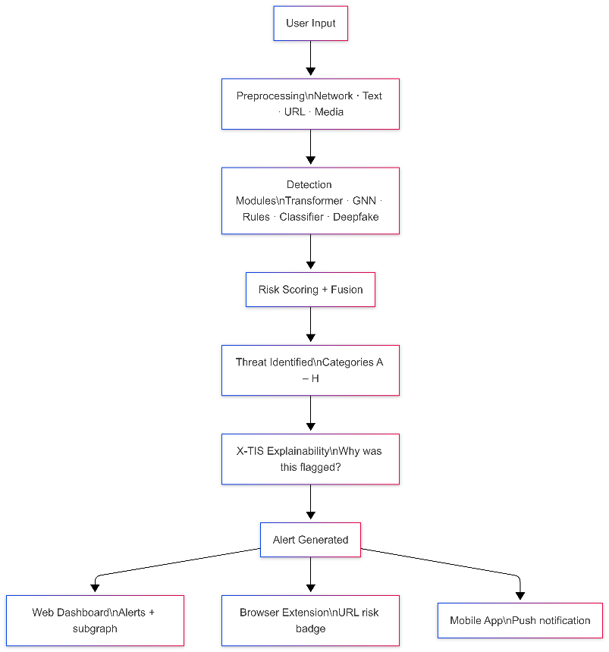
- Interface Layer

Fig 1. System Architecture

4.1.1 Input Layer

The entry point of the system. Users interact through one of three interfaces: the web platform for full dashboard access, the browser extension for real-time URL risk assessment while browsing, and the mobile application for on-the-go monitoring. Each interface forwards the input to the preprocessing layer after identifying its type.

4.1.2 Preprocessing Layer

Raw input is cleaned and transformed into a structured format suitable for detection. Network traffic captured as PCAP files is converted into 77-feature flow records using CICFlowMeter, followed by normalization and missing value handling. Text inputs are vectorized using TF-IDF. URLs undergo lexical feature extraction. Media inputs such as video, images, and audio are processed through frame extraction, face detection, and spectrogram generation respectively. The preprocessing layer ensures that every input arrives at the detection layer in a consistent, model-ready format.

4.2.3 Detection Layer

The core intelligence of the system. Five specialized modules sit in this layer, each targeting a different threat surface:

- The Transformer model analyzes individual network flows and assigns an attack probability score to each connection based on behavioral patterns learned from large-scale intrusion datasets.
- The GNN ensemble constructs a service-level graph from network traffic and identifies coordinated attack behavior patterns that only become visible when multiple services are observed together. This is the layer that catches multi-stage attacks that no single-flow model can detect.
- The Rule-based engine fires on known attack signatures and threshold violations, providing fast and reliable coverage for well-documented threat patterns.
- The Content classifier analyzes text inputs emails, SMS messages, and chat content to detect spam, phishing, scams, and social engineering attempts.

- The Deepfake detector identifies synthetic or manipulated media, flagging AI-generated video, images, and audio that may be used in deception campaigns.

For network traffic, the Transformer, GNN, and rule engine all run simultaneously. Their outputs are combined through a risk fusion step before passing to the next layer. For all other input types, only the relevant module activates.

4.2.4 Explainability Layer - X-TIS

Every detection, regardless of input type or module, passes through X-TIS (Explainability and Transparency Intelligence System) before an alert is raised. X-TIS uses SHAP values to explain network model detections, LIME to explain content classifier decisions, and frequency-domain attribution to explain deepfake detections. The output is a plain-language statement telling the user not just that a threat was found, but which specific signals caused the system to flag it. This makes the system usable by security analysts who need to investigate and act on alerts, not just receive them.

4.2.5 Interface Layer

The final layer delivers results to the user through the same three interfaces that accepted the input. The web dashboard presents the full picture alerts, risk scores, X-TIS explanations, and for network threats, a visual subgraph showing which services are involved. The browser extension overlays a risk badge directly onto URLs as the user browses. The mobile application sends push notifications for high-severity alerts so that critical threats are never missed.

CHAPTER 5 REQUIREMENTS

The IS-HAITI system is implemented as a hybrid cyber threat intelligence platform consisting of multiple analytical components including graph-based service risk detection, Transformer- based behavioral learning, fusion modeling, content threat detection, malicious URL analysis, and explainable intelligence generation.

Functional Requirements
Functional requirements describe the operations that the system must perform to achieve cyber threat analysis.

Input Handling

The system accepts five types of input: a URL pasted by the user, a text message or email body, an image, audio, or video file for deepfake analysis, a PCAP file for batch network analysis, and live network traffic captured via T-Shark or the browser extension. Each input type is routed to the correct module automatically.

Network Traffic Processing

For PCAP inputs, the system calls CICFlowMeter to generate 77-feature bidirectional flow records. For live traffic, T-Shark captures packets on a configurable interface and writes them to rolling PCAP files that CICFlowMeter processes. The resulting flow CSV feeds into the preprocessing step without manual intervention.

Transformer Model

The Transformer model is trained on NSL-KDD, CICIDS2017, and UNSW-NB15. During training it saves checkpoints and logs per-epoch metrics. During inference it takes a preprocessed flow CSV and outputs a per-flow attack probability score. These scores are exported to CSV and passed downstream to the GNN.

5.1.4 Graph Neural Network

The GNN takes the service interaction graph built from aggregated Transformer scores and traffic statistics and outputs a per-service attack probability. It runs as an ensemble of three architectures (GCN, GAT, GraphSAGE). The output is a risk-ranked list of services and subgraph visualizations of the highest-risk clusters.

5.1.5 Rule-Based Engine

The rule engine runs on flow data alongside the ML models. It checks for: SYN flood patterns (high SYN ratio, small packet sizes), distributed brute force (high connection frequency from many distinct IPs in a short window), non-standard port usage for IRC-like services, and volume anomalies for potential exfiltration. When a rule fires, it raises the alert severity of any ML detection on the same service.

5.1.6 X-TIS Explainability

X-TIS runs after every detection. For Transformer and GNN outputs, it uses SHAP to compute which features contributed most to the prediction and in which direction. For content classifier outputs, it uses LIME to identify which words or phrases drove the classification. For deepfake outputs, it identifies which frequency-domain or spectral features triggered the alert. The explanation is always presented in plain language alongside the risk score.

5.1.7 Content and URL Detection

The content classifier uses TF-IDF with unigram and bigram features on SMS and email text

to detect spam, phishing, scam, and BEC. The URL module extracts 22 lexical features from each link including length, subdomain count, IP-as-hostname flag, URL shortener detection, entropy of path components, presence of brand keywords, and login-related keywords and scores each URL with a gradient-boosted classifier.

5.1.8 Deepfake Detection

For images: face regions are detected, a 2D DFT is applied, and a CNN trained on FaceForensics++ classifies based on frequency-domain patterns. For audio: MFCCs (40 coefficients) and LFCCs (40 coefficients) are extracted and an LSTM classifier identifies synthetic speech. For video: the image detector runs on sampled frames and temporal consistency between frames is also checked.

5.1.9 Continuous Learning and Drift Detection

ADWIN monitors incoming flow features for distribution changes. When drift is detected across multiple features, an incremental update is triggered: the Transformer classification head is updated using SGD with a reduced learning rate on the most recent data, combined with a replay buffer of historical samples to prevent forgetting. Full retraining is triggered when cumulative drift exceeds a threshold.

Non-Functional Requirements
    - Performance Requirements

        - Scalability: The system architecture should support processing of larger intrusion detection datasets and additional threat intelligence sources without major redesign. The modular pipeline must allow integration of new datasets, models, and detection modules in future extensions.

        - Reliability: The system should generate consistent detection results when executed multiple times on similar input data. Model training, inference, and fusion processes must maintain stable performance across different datasets

        - Usability: Detection outputs should be easily interpretable through structured CSV/JSON reports and human-readable explainability summaries (X-TIS reports), enabling understanding even for users without deep machine learning expertise.

        - Performance: The system should provide reasonable training and inference time using GPU acceleration and optimized preprocessing pipelines, ensuring efficient execution during experimentation and testing.

        - Maintainability: The codebase should follow modular design principles, allowing independent modification of preprocessing, Transformer training, GNN fusion, detection modules, and explainability components without affecting the entire system.

        - Security: The system should follow safe data handling practices, ensuring datasets are processed locally without unauthorized exposure, and all model outputs are generated within controlled experimental
environments.

Software Requirements

- Operating System: Windows 10 / Linux / macOS
- Programming Language: Python (Version 3.x)

AI/Machine Learning Frameworks:
  - PyTorch
  - TensorFlow (optional)

Supporting Libraries:
  - Scikit-learn
  - NumPy
  - Pandas
  - NetworkX / PyTorch Geometric (for graph modelling)

Visualization Tools:
  - Matplotlib
  - Seaborn

Development Environments:
  - Jupyter Notebook
  - VS Code or any Python IDE

Hardware Requirements

- A computer system with a minimum of Intel Core i5 processor or equivalent.
- 8 GB RAM or higher for smooth execution of machine learning models.
- At least 500 GB of storage for storing datasets, trained models, and project files.
- A GPU (such as NVIDIA GPU with CUDA support) is recommended for faster
- model training, though the system can also run on CPU for basic experiments.
- Stable internet connection for accessing datasets, libraries, and research resources.

CHAPTER 6 METHDOLOGY

This chapter explains how each part of the IS-HAITI pipeline actually works from receiving input to generating an explained alert. The workflow shown in Figure 2 below covers every stage: the three input interfaces, the input type router, four preprocessing paths, five detection modules, output fusion and risk scoring, eight threat categories, X-TIS explainability, and the three alert delivery channels.

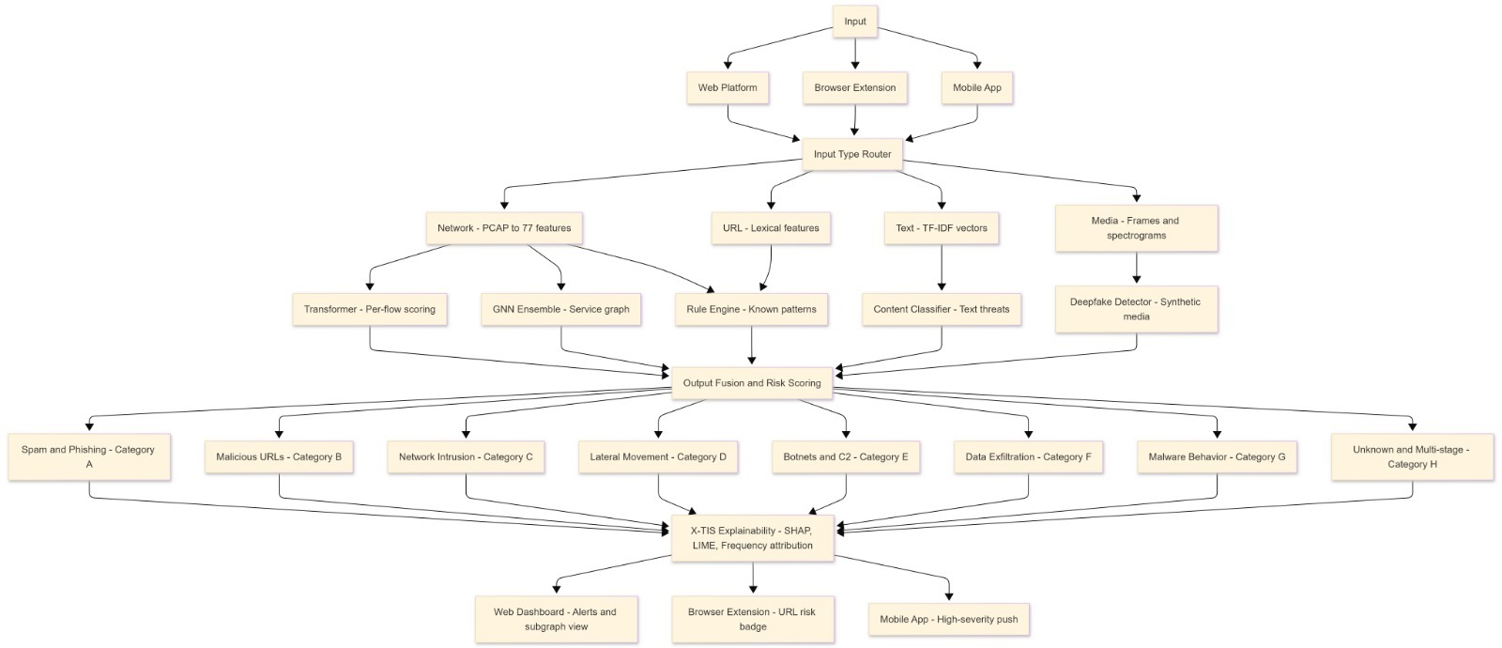

Fig 2: High-Level Workflow of the IS-HAITI Threat Detection System

Figure 1: illustrates the overall working flow of the proposed IS-HAITI threat detection system. The process begins when a user uploads network traffic data or log files into the system. This data is first passed through a preprocessing stage where it is cleaned, normalized, and converted into a suitable format for analysis.

6.1 Input and Interfaces

As shown in Figure 2, the system receives input through three interfaces: the Web Platform, the Browser Extension, and the Mobile App. Each interface is designed for a different use case but all three connect to the same backend pipeline.

The Web Platform is the main interface. It lets a user submit any type of input a URL, a text message or email body, a media file such as an image, audio, or video, or a PCAP file for network analysis. Results are displayed on screen with the full alert details, risk score, and X-TIS explanation. For network threats, a visual subgraph of the affected services is also shown. The platform keeps a running alert history so security teams can review past detections and update alert status.

The Browser Extension runs passively as the user browses. Every time a page loads, the URL is checked by the detection backend and a risk badge appears on the browser toolbar. If the URL is flagged, a tooltip shows the X-TIS reason directly in the browser without the user needing to open the dashboard. The Mobile App connects to the backend through a secure API. Its main function is to send push notifications when High severity alerts are generated, so analysts are notified even when they are away from the dashboard. From the app, the analyst can read the full alert detail and mark it as reviewed, escalated, or dismissed.
6.2 Input Type Router

Once input arrives from any of the three interfaces, it passes through the Input Type Router. This step identifies what type of input was submitted and decides which preprocessing path and detection modules should be activated.

The router checks the MIME type of any uploaded file, the structure of text input to tell apart plain text from a URL, and which interface the submission came from. Based on this, the input is classified into one of four types: Network (PCAP files or live traffic captured via T-Shark), URL, Text, or Media. Only the modules relevant to that type are activated. A PCAP file does not trigger the content classifier or deepfake detector. A text message does not go through CICFlowMeter or the GNN. This routing is fully automatic the user does not select a module manually.
6.3 Preprocessing

Before any detection module runs, raw input is converted into a form that the models can process. As shown in Figure 2, the four preprocessing paths are: Network PCAP to 77 features, URL Lexical features, Text TF-IDF vectors, and Media Frames and spectrograms.

Network Traffic: For PCAP input, CICFlowMeter parses the file and produces one row per bidirectional flow. Each row has 77 features: forward and backward packet length statistics (mean, max, min, standard deviation), inter-arrival time statistics in both directions, TCP flag counts, flow duration, subflow byte and packet averages, and active/idle time statistics. For live traffic, T-Shark captures packets on a configurable interface and writes them to rolling PCAP files that CICFlowMeter processes.

Raw CICFlowMeter output has two known problems. When flow duration is zero, rate feature calculations produce infinite values. Incomplete flows produce missing values. Infinite values are replaced with the per-feature training maximum and missing values are filled with training medians. Categorical fields like protocol and service name are integer-encoded. All numerical features are then Min-Max normalized using parameters fitted on the training data only, so no test or live data information leaks into normalization. Using the same CICFlowMeter tool for both training preparation and live inference is a deliberate design choice it ensures the model always sees feature values computed the same way.

URL Input: 22 lexical features are extracted directly from the URL string without visiting the page. These include URL length, number of subdomains, whether the hostname is an IP address, whether a URL shortener is in use, entropy of the path components, presence of brand-name

keywords that could indicate impersonation, presence of login-related keywords such as 'verify' or 'account', count of special characters, and top-level domain type.

Text Input: SMS messages and email bodies are lowercased, stop words are removed, and TF-IDF vectorization is applied with unigrams and bigrams. If the message contains URLs, those are extracted and sent through the URL preprocessing path as well.

Media Input: For images, a face detector identifies face regions first. For video, frames are sampled at regular intervals and the image-level detector is applied to each sampled frame. For audio, 40 MFCC coefficients and 40 LFCC coefficients are extracted from 25 ms frames with a 10 ms hop between frames. These coefficients capture the spectral shape of each audio frame, which reflects the vocal tract characteristics of the speaker and differs clearly between real and synthetic speech.

6.4 Transformer Model Per-Flow Scoring

The Transformer model is the first detection layer for network traffic. It works at the individual flow level and assigns an attack probability to each connection. The architecture follows a feature tokenization design: each of the 77 flow features is projected to a 64-dimensional embedding using a learned linear layer, converting a flat row of numbers into a sequence of 77 vectors. These 77 vectors are passed through 4 Transformer encoder layers with 8 attention heads each.

The attention mechanism allows the model to learn which combinations of features matter for a prediction. For example, it can learn on its own that high SYN count combined with small packet size is a strong indicator of a port scan, without being given that rule explicitly. After the encoder layers, a classification head of two fully connected layers with ReLU activation and 0.3 dropout produces a single output value. A sigmoid converts this to a probability between 0 and 1. This is the per-flow attack probability that is passed into the service graph construction step.Training uses Binary Cross-Entropy loss with class weights that are the inverse of class frequency, to handle the imbalance between benign and attack flows in intrusion detection datasets. The optimizer is Adam with learning rate 1e-3, weight decay 5e-5, batch size 4096,

and gradient clipping at norm 1.0. Training runs for up to 100 epochs with early stopping at patience 15 based on validation loss. The checkpoint with the best validation ROC-AUC is kept for deployment. The model is trained on NSL-KDD, CICIDS2017, and UNSW-NB15.

6.5 Service Graph Construction and GNN Ensemble

After the Transformer scores each flow, those scores are aggregated per service. A service is identified by mapping the destination port of each flow to a known service name. For each service, the system computes: mean and maximum attack probability across all flows to that service, standard deviation of attack probabilities, total flow count, mean and standard deviation of source and destination byte counts, TCP/UDP/ICMP protocol ratios, count of distinct source IPs, and burst rate in flows per second. These values form the node feature vector for that service in the graph.

An edge is drawn between two services whenever direct communication between them appears in the flow data. The edge weight equals the number of flows between that pair. The graph is stored as a PyTorch Geometric Data object with the node feature matrix, edge index, edge weights, and node labels from the dataset ground truth. For NSL-KDD, this process produces 70 service nodes.

Three GNN architectures are trained independently on this service graph:
        - GCN (Graph Convolutional Network): each node aggregates a normalized weighted sum of its neighbour’s features at each layer. Three convolution layers allow information to travel up to three hops through the graph. GCN is good at picking up local structural patterns around each service.
        - GAT (Graph Attention Network): similar to GCN but the aggregation weights are learned through an attention mechanism. This lets the model figure out which neighbouring services carry more useful information for each node being classified.

        - GraphSAGE: samples a fixed number of neighbours at each layer instead of using the full neighbourhood. This makes it scalable to larger graphs and the sampling introduces regularization.

All three use hidden dimension 64,3 message-passing layers, dropout 0.3, and learning rate 1e-3. Each model produces a per-node attack probability. The final score for each service is a weighted average of the three outputs, with weights tuned on the validation set to maximize F1-score. Using an ensemble consistently outperforms any single GNN architecture.

This GNN layer is what allows IS-HAITI to detect multi-stage and coordinated attacks. If several services around a node are showing attack-linked behavior, that node's risk score rises even if its own individual traffic looks normal. This cross-service pattern is exactly what port scanning, lateral movement, and botnet activity look like and it is invisible to any model that only looks at one flow at a time.
6.6 Rule-Based Engine Known Patterns

The rule engine runs at the same time as the Transformer and GNN on the same network flow data. It applies four checks:
- Port scan / SYN flood: more than 95% of flows to a service have the SYN flag set and
mean packet size is below 100 bytes.
- Distributed brute force: more than 500 flows to a service from more than 50 distinct
source IPs within one minute.
- C2 indicator: a service identified as IRC-like by name or by port number (known IRC
ports 6660–6669) is receiving connections on non-standard ports.
- Exfiltration indicator: total destination bytes for a service exceed 5 standard deviations
above its historical mean in the current measurement window.

When a rule fires on a service that the GNN also flagged, the alert severity is raised to High. When only a rule fires, severity is Medium. When only the GNN flags something, severity is Low or Medium depending on the probability score. This three-level scheme tells the analyst exactly how much confidence to place in each alert. The rule engine handles known patterns reliably while the GNN catches newer and more complex behavior together they cover more ground than either can alone.

6.7 Content Classifier and URL Analyzer

When input is a text message or email body, the content classifier runs. It uses TF-IDF with unigram and bigram features to represent the text. The classifier is a gradient-boosted model trained to detect spam, phishing, scam messages, and Business Email Compromise (BEC). Training data includes the SMS Spam Collection dataset with 5,574 labeled messages and labeled email datasets. If the message contains URLs, those are automatically extracted and passed to the URL analyzer as well.

The URL analyzer takes the 22 lexical features extracted during preprocessing and scores each URL using a separate gradient-boosted classifier. It identifies malicious links and credential harvesting sites based on the structure of the URL alone, without visiting the page. This makes the module both safe and fast. Features like IP-as-hostname, login keywords in the path, brand keywords that suggest impersonation, URL shortener detection, and suspicious TLD type are the main signals the classifier uses.

Both classifiers output a probability between 0 and 1. Anything above the detection threshold passes to X-TIS for explanation and is turned into an alert. When a message contains a URL, the combined signal from both the text classifier and the URL analyzer is used a suspicious message containing an also-suspicious URL raises the overall confidence of the detection.

6.8 Deepfake Detection Pipeline

When an image is submitted, face regions are detected first. Each detected face is transformed into the frequency domain using a 2D Discrete Fourier Transform (2D DFT). GAN-generated images have characteristic upsampling artifacts regular periodic patterns in the high-frequency part of the spectrum that photographs taken by a real camera do not have. A ResNet-based CNN trained on the FaceForensics++ benchmark classifies each face region as real or synthetic based on these spectral patterns.

For video input, the same image-level detector runs on frames sampled at regular intervals. A temporal consistency check is also applied across consecutive frames. Face-swap deepfakes

often produce small but detectable inconsistencies in how the face moves from frame to frame the temporal check picks up this pattern even when individual frames are borderline.

For audio input, the 40 MFCC and 40 LFCC coefficients extracted during preprocessing are fed into an LSTM classifier trained on real and synthetic speech samples. Synthetic voices produced by neural text-to-speech systems have different formant transition patterns from natural speech. The LSTM processes the full sequence of coefficient frames and outputs a probability that the recording is synthetically generated. X-TIS then reports which frames and which coefficients deviated most from natural speech patterns.
6.9 Output Fusion, Risk Scoring, and Threat Categories

As shown in Figure 2, all module outputs feed into a single Output Fusion and Risk Scoring step. For network traffic, the Transformer per-flow scores, GNN per-service scores, and rule engine signals are combined here using the three-level severity scheme described in Section 6.6. For all other input types, the single module's probability score becomes the risk score directly.

After fusion, every detected threat is assigned to one of eight categories. These eight categories cover every type of threat the system can detect across all input types:

- Category A Spam and Phishing: spam messages, phishing emails, scam content,
and Business Email Compromise detected by the content classifier.
- Category B Malicious URLs: phishing websites, fake login pages, credential harvesting
sites, and brand impersonation links detected by the URL analyzer.
- Category C Network Intrusion: port scanning, service enumeration, and
reconnaissance activity detected by the Transformer and rule engine.
- Category D Lateral Movement: SMB-based lateral movement, internal pivoting,
and NetBIOS attack patterns detected by the GNN through cluster behavior in the service graph.
- Category E Botnets and C2: IRC-based botnet behavior, HTTP/HTTPS beaconing,
and DNS tunneling detected by the Transformer and GNN on IRC and DNS service nodes.
- Category F Data Exfiltration: abnormal outbound data volume detected by the Transformer and the exfiltration rule.

- Category G Malware Behavior: backdoor communication, process memory
dump indicators, and persistence-linked traffic detected through GNN subgraph
analysis.
- Category H Unknown and Multi-Stage Attacks: attacks that span multiple
services over time and do not match a single signature, detected through structural
anomalies in the GNN service graph and flagged for analyst review.

6.10 X-TIS Explainability, SHAP, LIME, and Frequency Attribution

Every detection, from every module, passes through X-TIS Explainability and Transparency Intelligence System before an alert is sent. X-TIS answers one question for every detection: why was this flagged? Every alert the system delivers includes a specific readable reason, not just a threat label and a score. An analyst who gets an unexplained output cannot verify it or act on it confidently. X-TIS makes sure that never happens.

For Transformer detections: SHAP DeepExplainer computes the contribution of each of the 77 flow features to that prediction. The top 5 features by absolute SHAP value are shown. A positive value means the feature pushed the score toward attack; a negative value means it pushed away. Example output: 'Flagged because: high SYN count (↑), large source bytes (↑), low destination bytes (↓), high flag count (↑), short flow duration (↑).'

For GNN detections: gradient-based attribution computes how much each node feature of the flagged service influenced its classification. The 2-hop subgraph around that service the service itself, its direct neighbours, and their neighbours is extracted and shown as a graph diagram. Nodes are coloured by risk: green for low, orange for medium, red for high. The analyst can see exactly which cluster of services is behaving suspiciously together.

For rule-based detections: the explanation is the rule that fired and the actual values that triggered it. For example: 'Rule triggered: SYN ratio 0.97, mean packet size 48 bytes matches port scan pattern.' No additional attribution is needed the rule itself is the explanation.

For content classifier detections: LIME builds a local linear model around the specific message. It generates many modified versions of the message dropping or replacing words runs the classifier on all of them, and fits a linear model to the pattern of outputs. The words that contributed most to the classification are shown. Example: 'Flagged because: words [click, verify, account, expires] were strong indicators of phishing.'

or URL detections: the top-contributing lexical features are listed. Example: 'Flagged because: IP address used as hostname, login keyword found in path, suspicious TLD detected.'

For deepfake detections: for images, the frequency bands that showed GAN upsampling artifacts are identified. For audio, the MFCC and LFCC frames that deviated most from natural speech are highlighted, showing exactly where in the recording the synthetic signal was strongest.

The X-TIS explanation is always presented in plain language next to the risk score. A user without a machine learning background should be able to read it and understand why the system flagged something.

6.11 Alert Generation and Delivery

After X-TIS produces the explanation, a structured alert is assembled containing the threat category, severity level, risk score, and the plain-language X-TIS explanation. As shown in Figure 2, the alert is delivered through one of three channels: Web Dashboard, Browser Extension, or Mobile App.

Through the Web Dashboard, the full alert is displayed. For network threats, the visual subgraph of the involved services is shown alongside the explanation and risk score. The dashboard also maintains a running alert history where teams can filter by category or severity, and mark each alert as reviewed, escalated, or dismissed.

Through the Browser Extension, a risk badge appears on the URL in the browser toolbar as soon as analysis is complete. If the URL is flagged, the badge shows a warning and a tooltip shows the X-TIS reason in context the user does not need to leave the browser.

CHAPTER 7 EXPERIMENTATION

Part 1 experimentation:

: Overview
This phase transforms raw network traffic flows into a structured graph representation suitable for threat detection. The pipeline consists of four main stages:
      - Network Flow Extraction (source/destination IPs, ports, protocols)
      - Statistical Feature Aggregation (packet counts, byte volumes, temporal patterns)
      - Graph Construction (services as nodes, communication patterns as edges)
      - Node Classification Preparation (binary classification: safe vs. attack-linked)
This workflow was applied consistently to the NSL-KDD and CICIDS datasets to ensure reproducibility across different network attack scenarios.

Data Preprocessing Pipeline

Flow-Level Extraction
- Raw network traffic from PCAP files and CSV datasets is parsed using network analysis tools (Wireshark, pyshark, pandas-compatible parsers)
- Each flow is characterized by:
- Source IP and Port
- Destination IP and Port
- Protocol (TCP, UDP, ICMP)
- Packet count, total bytes transferred
- Flow duration (start/end timestamps)
- Traffic direction (bidirectional aggregation)

Service Identification and Node Creation
- Destination ports are mapped to well-known services (HTTP, SSH, FTP, DNS, etc.)
- Each unique service becomes a node in the network graph
- Nodes store aggregated features:
- avg_packet_size – Mean bytes per packet

- flow_count – Total number of flows to this service.
- total_bytes – Sum of bytes across all flows
- duration_stats – Mean, std of flow durations
- protocol_distribution – Ratio of TCP/UDP/ICMP flows
- attack_probability – Binary label from dataset (0=safe, 1=attack)

Temporal Feature Extraction
For time-aware analysis, the following features are computed per service:
- Burst Detection: Time intervals between flows; high frequency ≈ suspicious
- Temporal Concentration: % of activity in peak hours vs. off-peak hours
- Flow Seasonality: Consistency of traffic patterns across time windows

Statistical Feature Aggregation
For each service node, the following 12-dimensional feature vector is constructed:
- avg_packet_size – Mean packet size (bytes)
- flow_count – Number of unique flows
- total_bytes – Total data transferred
- mean_duration – Average flow duration
- std_duration – Std dev of flow durations
- tcp_ratio – Fraction of TCP flows
- udp_ratio – Fraction of UDP flows
- icmp_ratio – Fraction of ICMP flows
- unique_sources – Distinct source IPs connecting to this service
- unique_destinations – Distinct destination Ips
- burst_rate – Flows per second (temporal density)
- protocol_entropy – Entropy across protocol types

Graph Construction

Edge Definition
Edges connect services that communicate directly in the network:
- Directed edges represent communication direction (client → server convention)
- Edge weight = frequency of inter-service communication
- Self-loops are included for services with internal traffic patterns

Example: If HTTP service (port 80) receives 50 flows from SSH service (port 22), an edge is created with weight = 50.

Graph Representation
- Adjacency Matrix A ∈ ℝ^(N×N) where N = number of unique services
- Feature Matrix X ∈ ℝ^(N×12) where each row is a service's feature vector
- Label Vector y ∈ {0,1}^N indicating safe (0) or attack-linked (1) services
The complete graph G = (V, E, X, y) is stored in PyTorch Geometric format for efficient GNN processing.

Dataset Normalization and Balancing

Feature Scaling
All 12 features are scaled to [0, 1] range using Min-Max normalization:
- x_scaled = (x - x_min) / (x_max - x_min)
- Per-feature normalization ensures equal contribution regardless of magnitude differences

Class Balancing
Original dataset exhibited significant class imbalance (90% safe, 10% attack-linked):
- Oversampling minority class: Attack-linked services up-sampled using SMOTE (Synthetic Minority Over-sampling Technique)
- Sampling strategy: Balanced to 60% safe / 40% attack-linked ratio during training
- Test split: Kept at original imbalance ratio (90/10) for realistic evaluation

Training Configuration
- Optimizer: Adam (Learning Rate = 1e-3, Weight Decay = 5e-5)
- Loss Function: Binary Cross-Entropy with Logits (BCEWithLogitsLoss)
- Epochs: 100 with Early Stopping (patience = 15 epochs)
- Device: GPU (CUDA) when available; CPU fallback
- Training Output: 70% / 15% / 15% stratified split
- Output : Per-node predicted probability of being attack-linked

Output
The final output of Part 1 includes:
- Normalized feature matrix and adjacency matrix in PyTorch Geometric format
- Service-level labels with attack probability scores
- Dataset statistics: node count, edge density, feature distributions
- Diagnostic plots: feature correlation heatmaps, class distribution before/after balancing

Phase 2: Graph Neural Network Training and Attack Detection

Overview
This phase focuses on training multiple GNN architectures to classify network services as safe or attack-linked based on their local topology and feature patterns. The objective is to identify compromised or suspicious services that exhibit abnormal communication behavior.
Target classes: Safe (0) and Attack-Linked (1)

GNN Architecture Design

Graph Convolutional Network (GCN)
- Layer Structure: Input → GCN(64) → GCN(32) → MLP(16) → Output(1)
- Activation: ReLU between layers, Sigmoid on output
- Mechanism: Aggregates features from 1-hop neighborhood; effective for local patterns
- Invalid Advantage: Lightweight, interpretable, efficient on sparse graphs

Graph Attention Network (GAT)
- Layer Structure: Input → SAGE(64, mean aggregation) → SAGE(32, mean
aggregation) → MLP(16) → Output(1)
- Aggregation Function: Mean pooling over neighbor features
- Sampling Strategy: Fixed-size neighborhood sampling (sample_size = [25, 10] per layer)
- Advantage: Scalable to large graphs; effective for inductive learning on unseen services

Hybrid GNN Ensemble

- Combines predictions from GCN + GAT + GraphSAGE with weighted voting
- Weights learned on validation set to maximize F1-score
- Ensemble consensus reduces false positives and improves robustness

Hyperparameter Tuning Strategy

Systematic Grid Search
- Hidden Dimensions: {32, 64, 128}
- Number of Layers: {2, 3, 4}
- Small Dropout Rate: {0.0, 0.3, 0.5}
- Learning Rate: {1e-4, 1e-3, 1e-2}
Best configuration identified:
- Hidden Dim: 64
- Layers: 3
- Dropout: 0.3
- Learning Rate: 1e-3

Early Stopping Criteria
- Monitor validation loss every 5 epochs
- Stop if no improvement for 15 consecutive epochs
- Restore best model weights before final evaluation

Model Training Details

Loss Function
Binary Cross-Entropy with Logits:
$$\mathcal{L} = -\frac{1}{N} \sum_{i=1}^{N} [y_i \log(\sigma(z_i)) + (1-y_i) \log(1-
\sigma(z_i))]$$
where z_i is the logit output and σ is the sigmoid function.

Regularization Techniques
- Dropout: 0.3 rate in hidden layers to prevent overfitting
- L2 Regularization: Weight decay = 5e-5 on all parameters
- Graph Regularization: Implicit through message-passing design

Training Loop
Per epoch:
- Forward pass through selected GNN architecture

- Compute loss on training set (with class weights for imbalance)
- Backward pass; optimizer step
- Evaluate on validation set; check early stopping criterion
- Log metrics: Loss, Accuracy, Precision, Recall, F1

Hardware and Software Specifications
- Programming Language: Python 3.8+
- Deep Learning Framework: PyTorch 1.10+
- Graph Processing: PyTorch Geometric (torch-geometric)
- Data Processing: pandas, NumPy, scikit-learn
- Visualization: Matplotlib, NetworkX, Plotly

Hardware:
  - NVIDIA GPU (RTX 2080 Ti or equivalent) for accelerated training
  - Intel i7 / Ryzen 7 equivalent CPU
  - 32 GB RAM minimum
- Operating System: Linux (Ubuntu 18.04+) or Windows 10/11 with WSL2

Input and Output Structure Input

Graph Representation:
- Adjacency matrix A (sparse, CSR format)
- Node feature matrix X (N × 12 dense matrix)
- Node labels y (N-dimensional binary vector)

Sample Input Dimensions:
- N = 80–150 unique services (varies by dataset)
- 12 hand-crafted features per node
- Edge density: 5–15% (sparse graph typical)

Output

Per Service Node:
- Predicted Probability: P(attack) ∈ [0, 1]
- Classification: 1 if P(attack) > 0.5, else 0
- Confidence Score: |P(attack) - 0.5| (distance from decision boundary)

Aggregate Metrics:
- Confusion matrix (service-level classification distribution)

- Precision, Recall, F1-score, ROC-AUC on test set
- Service-wise predictions exported to CSV

Evaluation Metrics

Classification Metrics
- Accuracy: $(TP + TN) / (TP + TN + FP + FN)$
- Precision: $TP / (TP + FP)$ – Fraction of detected attacks that are true
- Recall: $TP / (TP + FN)$ – Fraction of actual attacks detected
- F1-Score: $2 \cdot \frac{\text{Precision} \times \text{Recall}}{\text{Precision} +
\text{Recall}}$
- ROC-AUC: Area Under the ROC curve; tolerance for probability thresholds

Graph-Specific Metrics
- Community Detection: Modularity of detected attack clusters
- Centrality Correlation: Betweenness/degree centrality vs. attack probability
- Subgraph Cohesion: Density of attack-linked service clusters

Phase 3: Attack Pattern Discovery and Threat Categorization

Subgraph Extraction
Attack-linked services identified by the GNN are grouped into threat clusters:
- Connected Component Analysis: Find connected subgraphs of attack services
- K-Hop Expansion: Include neighbors of attack services to identify attack propagation
- Subgraph Visualization: Generate network diagrams highlighting threat paths

Risk Scoring
Services are ranked by attack probability and integrated risk:
$$\text{Risk Score} = \alpha \cdot P(\text{attack}) + \beta \cdot \text{Centrality} + \gamma
\cdot \text{Cluster Size}$$
- $\alpha = 0.5$ – Attack probability weight
- $\beta = 0.3$ – Network centrality weight (how many other services connect)
- $\gamma = 0.2$ – Attack cluster size weight
- Ranking identifies top-N services for prioritized investigation

CHAPTER 8 RESULTS

Network Graph Visualization and Structural Analysis

    - Service–Protocol Interaction Graph (NSL-KDD / KDD-derived)

The service interaction network is represented as a service graph, where:
- Nodes represent unique network services (e.g., http, domain, ftp, irc).
- Edges represent service relatedness derived from protocol neighborhood connectivity.
- The graph used for the core service-level experiments contains 70 services.

This graph formulation is important because malicious behavior is rarely isolated to a single service. Instead, related services (by protocol usage and communication neighborhoods) often show correlated anomalous signals. The graph allows the model to learn context-aware threat intelligence, where a service risk score can be influenced by its neighbors.

Node Color Scheme (Risk Heatmap)
In all graph visualizations, node color encodes the model’s predicted probability of being attack-linked.

Service node coloration scheme
      - Low risk:
      - Medium risk:
      - High risk: 𝑃(𝑎𝑡𝑡𝑎𝑐𝑘) ≥ 0.70

Node size is proportional to node connectivity (degree), highlighting high-traffic hub services (e.g., HTTP/DNS) versus smaller peripheral services that may still show high risk.

GNN Model Performance and Robustness (Service-Level)
    - Experimental Setup (No-Leak Evaluation)
To avoid target leakage, we report a strict no-leak evaluation using only the following aggregated service features:
      - src_bytes_mean (mean source bytes per service)
      - dst_bytes_mean (mean destination bytes per service)
      - count (number of aggregated connections per service)

The label is binary: whether the service is attack-linked (based on historical attack presence in the underlying connections).

ROC Analysis (No-Leak)

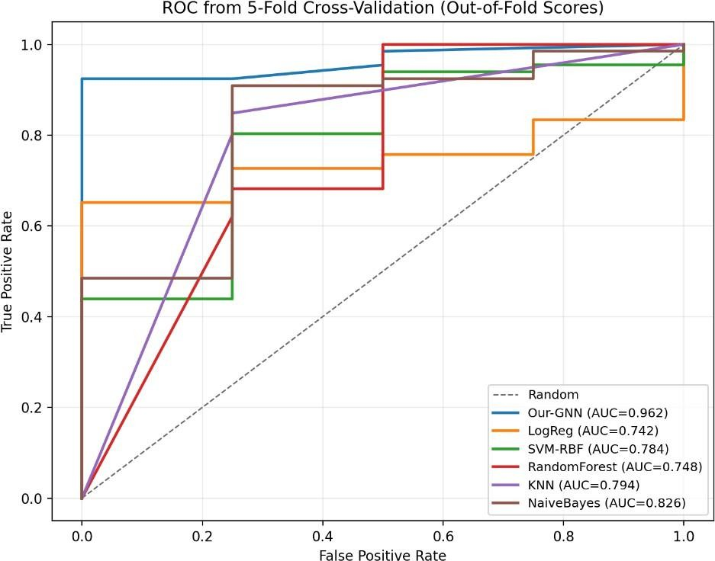

Fig 3: Pooled ROC curves (Our-GNN vs baselines, 5-fold CV)

The ROC curve indicates strong separability between attack-linked and benign services across thresholds.

Quantitative Results (No-Leak)
We emphasize 5-fold stratified cross-validation (CV) and pooled out-of-fold scoring for stable reporting.

Our-GNN (No-Leak, 5-fold CV, pooled)
      - Accuracy: 0.9286
      - Precision: 1.0000
      - Recall: 0.9242
      - F1-score: 0.9606
      - ROC-AUC: 0.9621

Interpretation
The key advantage of the GNN is message passing, enabling a service to inherit risk context from its neighborhood. This aligns with security reality: related services/protocols often participate jointly in multi-stage attacks (C2, lateral movement, exfiltration).

Attack Risk Stratification (Service Ranking)
    - Top-Risk Services
The system produces a ranked list of services by predicted attack probability, supporting analyst prioritization (monitoring, blocking, segmentation, alert tuning).
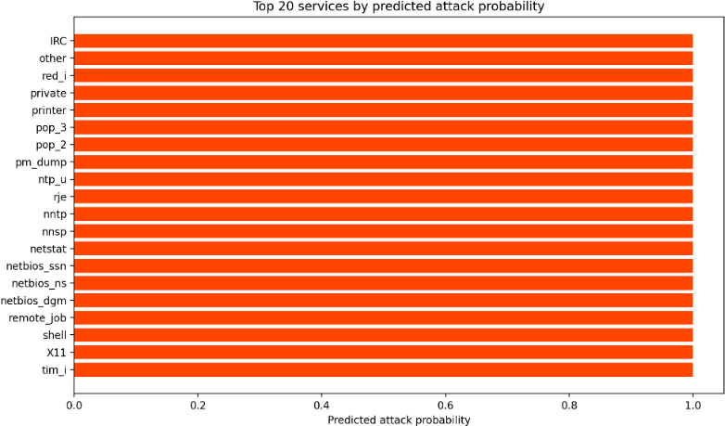
Fig 4: Top services by predicted attack probability

Practical Security Meaning
High-risk scores for uncommon or legacy services (e.g., IRC-like, P2P-like, unusual ports) are treated as strong indicators for compromise or policy violations in enterprise settings.

Fine-Grained Attack Pattern Analysis using X-TIS (Explainability)
- TIS-style explainability is provided at two levels:
  - Feature attribution: highlights which service features most contribute to the risk score.
  - Subgraph visualization: extracts the local neighborhood around a high-risk service to show how risk may propagate through related services.

Subgraph 1 IRC-Mediated Command-and-Control (C2)
Interpretation: IRC-like services are frequently abused for botnet control channels. A high- risk IRC node with suspicious neighbors indicates potential C2 coordination and lateral spread.

Subgraph 2 NetBIOS/SMB-Style Lateral Movement Cluster

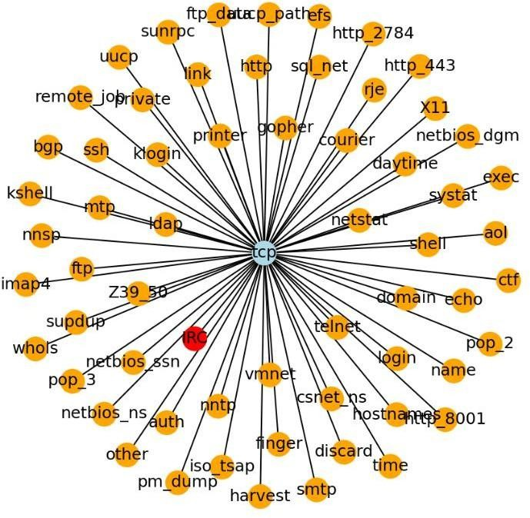

Fig 5: NetBIOS/SMB-related subgraph

Interpretation: Tight clustering around NetBIOS/SMB-related services is consistent with Windows lateral movement (credential reuse, remote execution, file share probing).

Subgraph 3 Credential Harvesting / Memory Dumping Signals

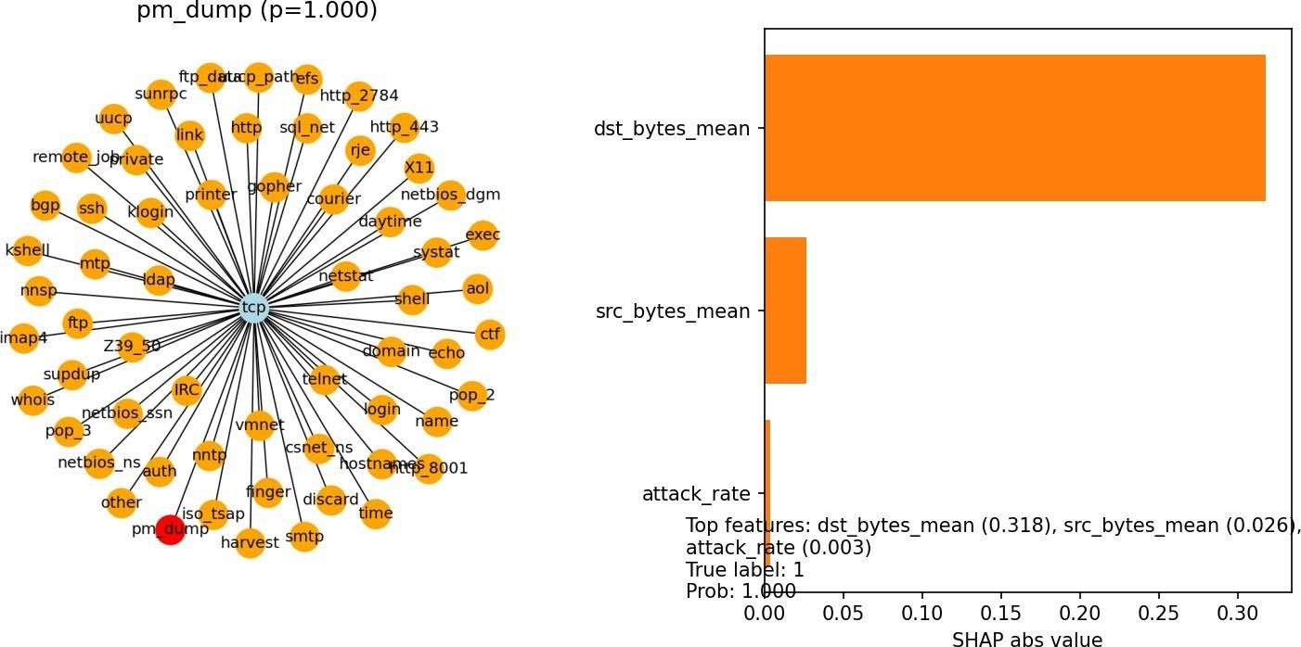

Fig 6: PM_Dump subgraph and attribution view

Interpretation: Process memory dumping is a common technique for extracting secrets and credentials, often preceding mail/service access and exfiltration.

Subgraph 4 DNS-based Command-and-Control / Tunneling Indicator
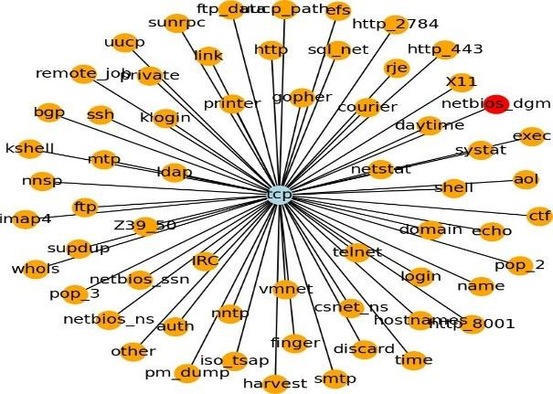
Fig 7: NetBIOS_DGM / DNS anomaly-style subgraph

Interpretation: DNS is frequently allowed through firewalls; anomalies around DNS/related services can indicate covert channels for C2 or data transfer.

Transformer Model Results (Flow-Level) and Fusion Results
    - Tabular Transformer Performance (per dataset)
A tabular Transformer (FT-Transformer-like) was trained to output 𝑃(𝑎𝑡𝑡𝑎𝑐𝑘) at the
flow/record level. Metrics below are taken from saved run artifacts.

KDD (validation / test)
      - Val: Accuracy 0.9948, F1 0.9944, ROC-AUC 0.99985
      - Test: Accuracy 0.9948, F1 0.9944, ROC-AUC 0.99982

CICIDS2017 (validation / test)
      - Val: Accuracy 0.9903, F1 0.9751, ROC-AUC 0.99927
      - Test: Accuracy 0.9954, F1 0.9884, ROC-AUC 0.99982

UNSW-NB15 (validation / test)
      - Val: Accuracy 0.9976, F1 0.9978, ROC-AUC 0.99995
      - Test: Accuracy 0.4002, F1 0.2626, ROC-AUC 0.63822 (PR-AUC 0.80590)

Discussion: The UNSW test degradation indicates dataset shift and/or label/feature distribution mismatch between splits. Therefore, we report both ROC-AUC and PR-AUC and treat test metrics as the realistic generalization indicator.

Fusion: Transformer → Service Aggregation → GNN
To bridge per-flow predictions with service-level threat intelligence, Transformer probabilities are aggregated into service node features and then processed by a GNN on a service graph.

KDD Fusion Results (service-level)
      - Services: 68
      - ROC-AUC (all services): 0.97266
      - Precision/Recall/F1: 0.94118 / 1.00000 / 0.96970

Detection-mode Output (Operational Report)
A detection script generates per-record risk scores and a best-effort categorization for network- style threats.

      - Rows processed (smoke run): 5000
      - Predicted attacks: 2361

Category A and Category B Threat Detection Results (Content + URLs)
    - Category A Spam / Phishing / Scam (Text Threats) + X-TIS Reports
A content-based detector was implemented to process SMS/email text (because flow datasets do not include message bodies). It outputs X-TIS-style explanations per message and generates a single-file HTML report for analyst review.

spam.csv (labeled)
      - Messages: 5572
      - Flagged: 302
      - Accuracy / Precision / Recall / F1: 0.9079 / 0.8874 / 0.3588 / 0.5110

SMSSpamCollection (labeled)
      - Messages: 5574
      - Flagged: 302
      - Accuracy / Precision / Recall / F1: 0.9080 / 0.8874 / 0.3588 / 0.5110

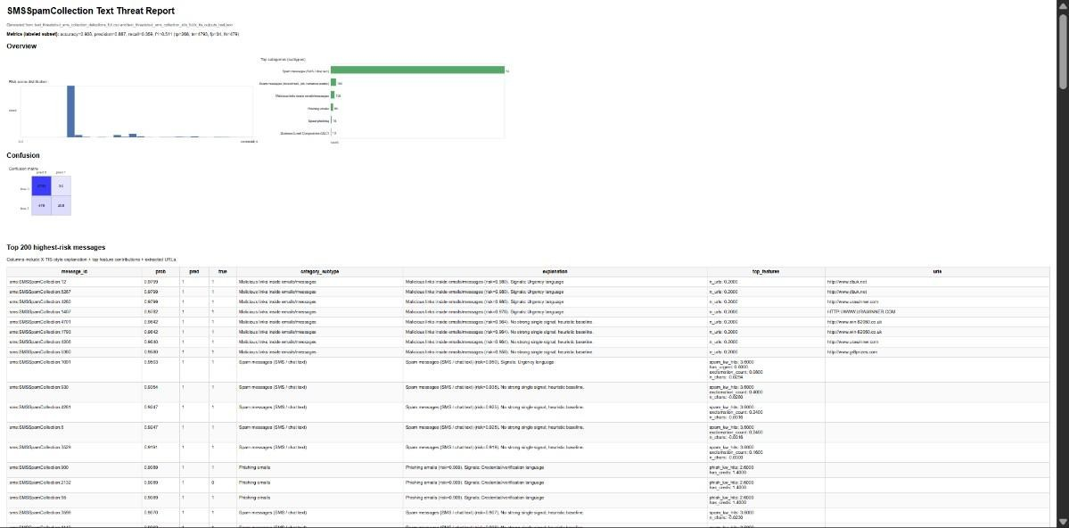

Fig 8:SMS Spam Collection Text Threat Analysis Report

easy_ham (unlabeled ham)
      - Messages: 2551
      - Flagged: 1650 (reported as a limitation of a heuristic baseline without calibration)

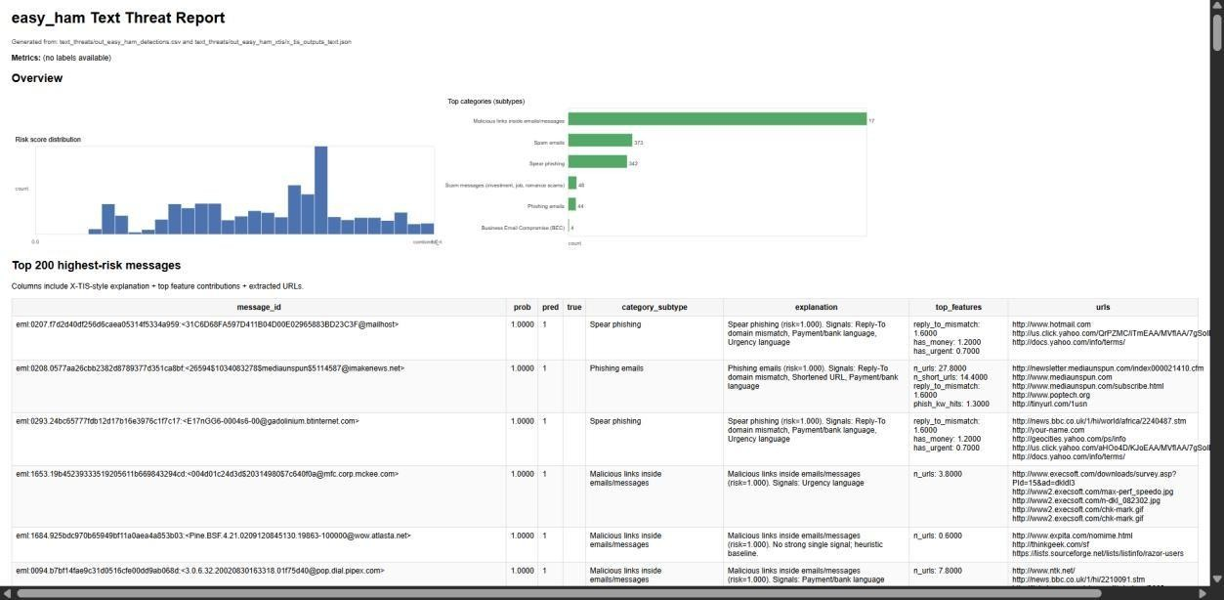

Fig 9:Easy Ham Email Text Threat Analysis Report

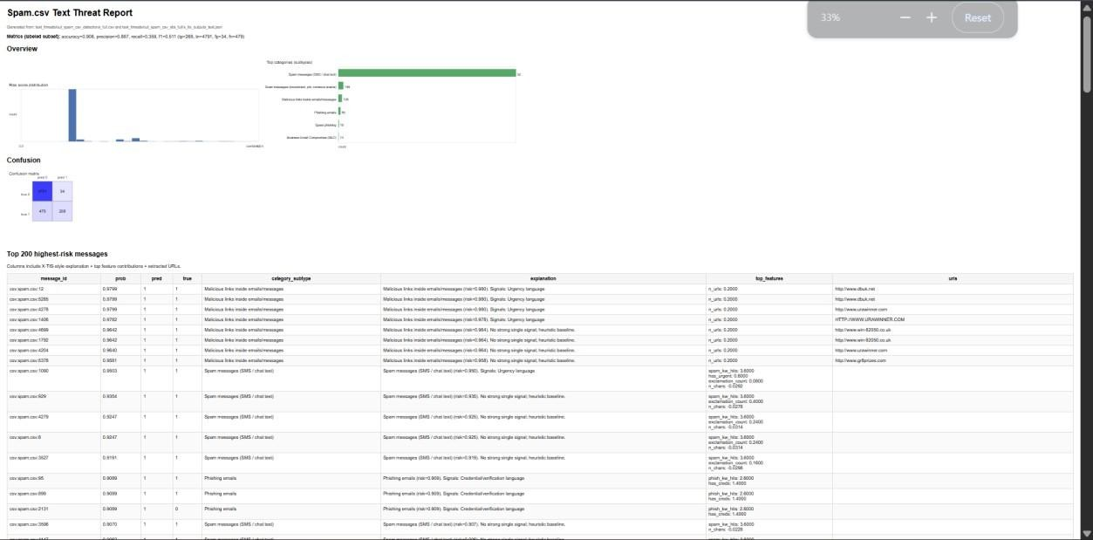

Fig 10: Screenshot of Category A HTML report (spam/phishing)

8.1 Category B Malicious URL & Website Attacks (URL Threats) + HTML Reports
A URL threat detector was implemented using offline lexical signals (shortener/IP/punycode/suspicious TLD/brand + login keywords/entropy). It produces per- URL risk scores and X-TIS-style top-feature explanations. HTML reports are generated for quick analyst interpretation.

Run summary (URLs extracted from messages)
      - URLs analyzed: 67
      - URLs flagged: 24
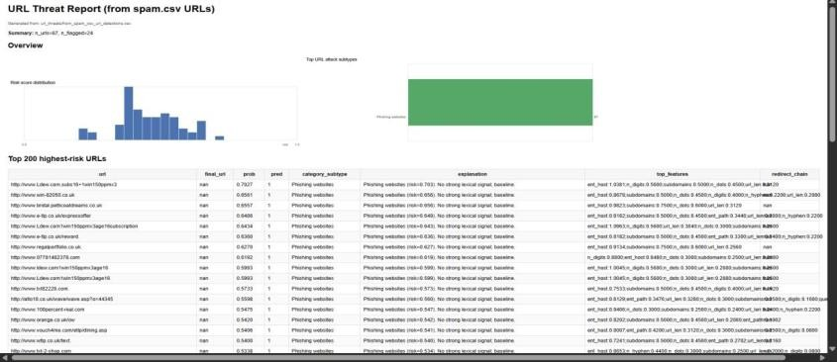
Fig 11: HTML Report Graph Based on attacks

CHAPTER 9 DELIVERABLES

Trained Threat Detection Models

    - Network record (flow) risk model
Deliverable: A trained machine-learning model that scores each network record as low to high risk.

What it does: For every row/connection in a network dataset, it outputs a risk score (think
“how likely this looks like an attack”).

Why it matters: This is the core “early warning” detector at the most detailed level (per connection).How a reviewer uses it: Run the provided evaluation script to reproduce the reported accuracy/ROC results, or run the detection script to produce a ranked list of risky records.

Service risk model (service-level graph model)

Deliverable: A trained machine-learning model that scores each network record as low to high risk.

What it does: Instead of scoring individual connections, it produces a risk score per service and uses a service-to-service relationship map so that related services can influence each other.

Why it matters: Service-level outputs are easier to act on in real operations (monitor, restrict,
or investigate a service), and the relationship map helps capture “attack context.”

Deliverable: A trained machine-learning model that scores each network record as low to high

risk.
How a reviewer uses it: Run the evaluation to reproduce the ROC curves and the ranked list of highest-risk services.

Hybrid (combined) pipeline model
Deliverable: A combined pipeline that links both ideas above into one system.

What it does:
- Scores individual connections (record-level risk),
- Summarizes those risks into service-level signals,
- Produces final service risk scores using the service relationship map.

Why it matters: It provides both detailed detection and an operational summary view, which is closer to how real security monitoring is performed.

Evaluation Results and Paper-Ready Tables/Figures

Paper-ready metrics tables
Deliverable: Tables of key performance numbers ready to paste into the report.

What it contains: Accuracy and other standard “how good is the detector?” scores (reported for Our‑GNN and baseline models under the no-leak setting).

Why it matters: This is the primary quantitative evidence supporting the service-level model claims.

Paper-ready ROC plots
Deliverable: ROC curve figures for the report.

What it shows: A standard accuracy curve that shows how detection quality changes as you move the alert threshold from strict to lenient, including baseline comparisons.

Narrative results write-up
Deliverable: A written results summary that matches the computed metrics.

Why it matters: Ensures the written report matches the actual computed metrics.

Explainability (X‑TIS) Artifacts

Service-level X‑TIS visuals
Deliverable: Visual explanations showing why the service risk model flagged something.

What it contains

      - Subgraph images showing which services are connected to a high-risk service (local
      - neighborhood context)
      - Attribution-style visuals indicating which features contributed most to the prediction

Why it matters: These artifacts justify model decisions and support “threat intelligence”
interpretation (C2 clusters, lateral movement clusters, etc.).

Text-level X‑TIS outputs (Category A)
Deliverable: Explainable detections for suspicious messages (spam/phishing/scam).

What it contains (per message):
      - Risk score and predicted subtype
      - Extracted URLs (when present)
      - Top contributing features that explain why a message was flagged
Why it matters: Makes content-based detections transparent and easy to audit.

URL-level X‑TIS outputs (Category B)
Deliverable: Explainable detections for suspicious links (malicious URLs/websites).

What it contains (per URL):

      - Risk score
      - Predicted URL subtype (best-effort)
      - Top URL features that contributed to risk (e.g., suspicious TLD, URL obfuscation, brand/login keywords)

Analyst-Friendly Reports (HTML)

Category A HTML reports (Spam/Phishing/Scam)
Deliverable: A clickable, human-readable report for message threat detection.

What it shows:
      - Score distribution plots
      - Counts of detected subtypes
      - Top-N flagged messages with explanations

Why it matters: A reviewer can open the report and understand results immediately without running code.

Category B HTML reports (Malicious URLs/Websites)
Deliverable: A clickable, human-readable report for suspicious link detection.

What it shows:
      - URL list with risk scores
      - Top contributing features per URL
      - Summary charts for quick review

Operational Scripts and Pipelines

Training and evaluation scripts

Deliverable: Runnable scripts to train the models and reproduce the metrics.

Why it matters: Supports repeatable experimentation and validation by a reviewer.

Threat detection scripts (inference)
Deliverable: Detection scripts that generate actionable outputs.

What they produce: CSV/JSON predictions plus HTML summaries (for text and URL threats).

Reproducibility artifacts
Deliverable: Saved run outputs used as evidence for the reported results.

What it contains: metrics summaries, evaluation reports, and run summaries generated at execution time.

Report Asset Bundle (One-Folder Submission)
Deliverable: One folder named “Report Assets” containing everything needed to assemble the
final PDF quickly.

What it contains:
- All report figures (PNG)
- The HTML reports (open in a browser and take screenshots)
- The tables/metrics used to write the Results chapter
- Sample CSV outputs as evidence of the pipeline

Why it matters: This prevents missing-figure issues and makes submission/review easier.

REFERENCES

- T. Kim, J. Lee, and S. Kim, “AI-driven transformer frameworks for real-time anomaly detection in network traffic,” International Journal of Advanced Computer Science and Applications (IJACSA), vol. 16, no. 3, pp. 112–124, 2025.

- M. Zhou, Y. Wang, and L. Chen, “Graph neural networks embedded with domain knowledge for network threat intelligence,” Proceedings of the ACM on Measurement and Analysis of Computing Systems, vol. 9, no. 1, pp. 1–23, 2025.

- A. Demir and H. Koc, “DeepGuard: A transformer-based framework for real-time cyber threat detection,” International Journal of Computer Engineering and Science, vol. 14, no. 2,
pp. 55–68, 2025

- R.Singh, P. Verma, and S. Choudhary, “Hybrid deep learning–based threat intelligence for malware detection,” Computers & Security, vol. 134, pp. 103–118, 2025.

- S. Miller and K. Brown, “Explainable artificial intelligence for cyber threat intelligence,”
Open Access Research Journal of Science and Technology, vol. 7, no. 1, pp. 1–12, 2025.

- N. Li, Q. Zhang, and Y. Xu, “Federated learning for collaborative cybersecurity
intelligence,” IEEE Security & Privacy, vol. 22, no. 1, pp. 48–57, 2024.

- J. Park, D. Kim, and H. Lee, “Daily insider threat detection using hybrid TCN–Transformer
architectures,” Scientific Reports, vol. 15, no. 1, pp. 1–14, 2025.

- L. Ahmed and M. Rahman, “Multimodel deep learning for online threat detection,” Journal of Information Security, vol. 16, no. 2, pp. 89–104, 2025.

- Y. Sun, X. Luo, and Z. Wang, “Software-defined networking and graph neural network– based DoS attack detection,” Future Generation Computer Systems, vol. 145, pp. 320–332, 2025.

- R.Singh, P. Verma, and S. Choudhary, “Hybrid deep learning–based threat intelligence for malware detection,” Computers & Security, vol. 134, pp. 103–118, 2025.

- A. Gupta and R. Patel, “Decentralized threat intelligence using federated learning,”
Expert Systems with Applications, vol. 231, pp. 120–134, 2025.

- S. Wang, H. Liu, and J. Zhao, “Transformer-based malware detection using system process logs,”Computers & Security, vol. 129, pp. 102–115, 2025.

- M. Lundberg and S. Lee, “A unified approach to interpreting model predictions,”
Advances in Neural Information Processing Systems (NeurIPS), vol. 30, pp. 4765–4774, 2017.

- P. Velickovic et al., “Graph attention networks,” International Conference on Learning Representations (ICLR), 2018.

- T. Kipf and M. Welling, “Semi-supervised classification with graph convolutional
networks,” International Conference on Learning Representations (ICLR), 2017.

- A. Vaswani et al., “Attention is all you need,” Advances in Neural Information Processing Systems (NeurIPS), vol. 30, pp. 5998–6008, 2017.

- N. Moustafa and J. Slay, “The evaluation of network anomaly detection systems: NSL- KDD dataset,” Proceedings of the International Conference on Intelligent Agents, Web Technologies and Internet Commerce, pp. 529–534, 2015.

- I. Sharafaldin, A. Lashkari, and A. Ghorbani, “Toward generating a new intrusion detection dataset and intrusion traffic characterization,” Proceedings of the 4th International Conference on Information Systems Security and Privacy (ICISSP), pp. 108–116, 2018.

- K. He, X. Zhang, S. Ren, and J. Sun, “Deep residual learning for image recognition,”
IEEE Conference on Computer Vision and Pattern Recognition (CVPR), pp. 770–778, 2016.

